1. Using DOM Navigation Create a TODO APP, it will show add new elements and delete

Elements

Todolist.html

<!DOCTYPE html>

<html lang="en">

  <head>

    <meta charset="UTF-8" />

    <meta http-equiv="X-UA-Compatible" content="IE=edge" />

    <meta name="viewport" content="width=device-width, initial-scale=1.0" />

    <title>Todo List</title>

    <link

      href="https://cdn.jsdelivr.net/npm/bootstrap@5.3.0-alpha3/dist/css/bootstrap.min.css"

      rel="stylesheet"

      integrity="sha384-KK94CHFLLe+nY2dmCWGMq91rCGa5gtU4mk92HdvYe+M/SXH301p5ILy+dN9+nJOZ"

      crossorigin="anonymous"

    />

    <script src="todolist.js"></script>

  </head>

  <body

    style="

      border: 1px solid black;

      background-color: rgba(245, 220, 109, 0.507);

    "

  >

    <div style="text-align: center; border: 1px solid black; height: 100vh">

      <h1 style="text-align: center">ToDo List</h1>

      <input

        style="margin-bottom: 15px; width: 500px; margin-left: 450px"

        class="form-control"

        type="text"

        id="inp"

        placeholder="Enter element"

      />

      <input

        style="margin-bottom: 10px"

        class="btn btn-secondary mb-3"

        type="button"

        value="Add element"

        onclick="addElement()"

      />

      <div id="parent"></div>

    </div>

  </body>

</html>

Todolist.js

function addElement() {

    let inptag = document.getElementById('parent')

    let currentval = inptag.innerHTML;

    let msgtag=document.getElementById('inp')

    let elemtag=msgtag.value;

    let newval=`<div><div style="display: flex; justify-content: space-between; padding: 5px; margin: 10px">

        ${elemtag}

        <input type="button" value="Clear" onclick="clr(this)" />

      </div>

      <hr />

      </div>`

    inptag.innerHTML = currentval + newval;

    msgtag.value = ' ';

}

function clr(p1) {

    p1.parentElement.parentElement.remove();

}

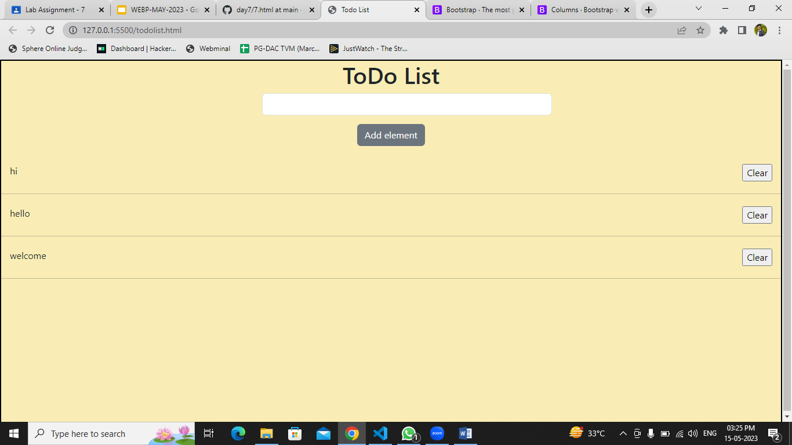

2. Create a static website using Bootstrap layout with Navbar,rows ,cols etc... and add to

try different features like accordion ,carrousal etc...

<!DOCTYPE html>

<html lang="en">

  <head>

    <meta charset="UTF-8" />

    <meta name="viewport" content="width=device-width, initial-scale=1.0" />

    <title>Nature Gallery</title>

    <link

      rel="stylesheet"

      href="https://maxcdn.bootstrapcdn.com/bootstrap/4.0.0/css/bootstrap.min.css"

    />

  </head>

  <body>

    <!-- Navbar -->

    <nav class="navbar navbar-expand-lg navbar-dark bg-dark">

      <a class="navbar-brand" href="#">Nature Gallery</a>

      <button

        class="navbar-toggler"

        type="button"

        data-toggle="collapse"

        data-target="#navbarNav"

        aria-controls="navbarNav"

        aria-expanded="false"

        aria-label="Toggle navigation"

      >

        <span class="navbar-toggler-icon"></span>

      </button>

      <div class="collapse navbar-collapse" id="navbarNav">

        <ul class="navbar-nav ml-auto">

          <li class="nav-item">

            <a class="nav-link" href="#gallery">Gallery</a>

          </li>

          <li class="nav-item">

            <a class="nav-link" href="#about">About</a>

          </li>

          <li class="nav-item">

            <a class="nav-link" href="#contact">Contact</a>

          </li>

        </ul>

      </div>

    </nav>

    <!-- Image Gallery -->

    <section id="gallery" class="py-5">

      <div class="container">

        <div class="row">

          <div class="col-md-4 mb-4">

            <img src="1.jpg" class="img-fluid" alt="Image 1" />

          </div>

          <div class="col-md-4 mb-4">

            <img src="2.jpg" class="img-fluid" alt="Image 2" />

          </div>

          <div class="col-md-4 mb-4">

            <img

              src="https://images.unsplash.com/photo-1470252649378-9c29740c9fa8?ixlib=rb-4.0.3&ixid=MnwxMjA3fDB8MHxwaG90by1wYWdlfHx8fGVufDB8fHx8&auto=format&fit=crop&w=870&q=80"

              class="img-fluid"

              alt="Image 3"

            />

          </div>

        </div>

      </div>

    </section>

    <!-- About Section -->

    <section id="about" class="py-5 bg-light">

      <div class="container">

        <div class="row">

          <div>

            <h2>About Nature Gallery</h2>

            <p>

              Nature, in the broadest sense, is the physical world or universe.

              "Nature" can refer to the phenomena of the physical world, and

              also to life in general. The study of nature is a large, if not

              the only, part of science. Although humans are part of nature,

              human activity is often understood as a separate category from

              other natural phenomena.The word nature is borrowed from the Old

              French nature and is derived from the Latin word natura, or

              "essential qualities, innate disposition", and in ancient times,

              literally meant "birth". In ancient philosophy, natura is mostly

              used as the Latin translation of the Greek word physis, which

              originally related to the intrinsic characteristics of plants,

              animals, and other features of the world to develop of their own

              accord. The concept of nature as a whole, the physical universe,

              is one of several expansions of the original notion;it began with

              certain core applications of the word by pre-Socratic philosophers

              (though this word had a dynamic dimension then, especially for

              Heraclitus), and has steadily gained currency ever since.

            </p>

          </div>

        </div>

      </div>

    </section>

    <div class="container">

      <div class="card text-bg-dark">

        <img

          style="width: 1150px; height: 50vh"

          src="https://images.unsplash.com/photo-1465056836041-7f43ac27dcb5?ixlib=rb-4.0.3&ixid=MnwxMjA3fDB8MHxwaG90by1wYWdlfHx8fGVufDB8fHx8&auto=format&fit=crop&w=871&q=80"

          class="card-img"

          alt="..."

        />

        <div class="card-img-overlay">

          <h5 class="card-title">Mountain</h5>

          <p class="card-text">

            The mighty chunks rise all over the world, including the oceans.

            They usually have steep, sloping sides and sharp or rounded ridges,

            and a high point, called a peak or summit.

          </p>

          <p class="card-text"><small>Last updated 3 mins ago</small></p>

        </div>

      </div>

      <hr />

      <div class="card text-bg-dark">

        <img

          style="width: 1150px; height: 50vh"

          src="https://images.unsplash.com/photo-1652122697559-9321f937d890?ixlib=rb-4.0.3&ixid=MnwxMjA3fDB8MHxwaG90by1wYWdlfHx8fGVufDB8fHx8&auto=format&fit=crop&w=870&q=80"

          class="card-img"

          alt="..."

        />

        <div class="card-img-overlay">

          <h5 class="card-title">Waterfall</h5>

          <p class="card-text">

            A waterfall is a river or other body of water's steep fall over a

            rocky ledge into a plunge pool below. Waterfalls are also called

            cascades. The process of erosion, the wearing away of earth, plays

            an important part in the formation of waterfalls. Waterfalls

            themselves also contribute to erosion.

          </p>

          <p class="card-text"><small>Last updated 3 mins ago</small></p>

        </div>

      </div>

    </div>

    <footer class="text-center text-white" style="background-color: #f1f1f1">

      <!-- Grid container -->

      <div class="container pt-4">

        <!-- Section: Social media -->

        <section class="mb-4">

          <!-- Facebook -->

          <a

            class="btn btn-link btn-floating btn-lg text-dark m-1"

            href="#!"

            role="button"

            data-mdb-ripple-color="dark"

            ><i class="fab fa-facebook-f"></i

          ></a>

          <!-- Twitter -->

          <a

            class="btn btn-link btn-floating btn-lg text-dark m-1"

            href="#!"

            role="button"

            data-mdb-ripple-color="dark"

            ><i class="fab fa-twitter"></i

          ></a>

          <!-- Google -->

          <a

            class="btn btn-link btn-floating btn-lg text-dark m-1"

            href="#!"

            role="button"

            data-mdb-ripple-color="dark"

            ><i class="fab fa-google"></i

          ></a>

          <!-- Instagram -->

          <a

            class="btn btn-link btn-floating btn-lg text-dark m-1"

            href="#!"

            role="button"

            data-mdb-ripple-color="dark"

            ><i class="fab fa-instagram"></i

          ></a>

          <!-- Linkedin -->

          <a

            class="btn btn-link btn-floating btn-lg text-dark m-1"

            href="#!"

            role="button"

            data-mdb-ripple-color="dark"

            ><i class="fab fa-linkedin"></i

          ></a>

          <!-- Github -->

          <a

            class="btn btn-link btn-floating btn-lg text-dark m-1"

            href="#!"

            role="button"

            data-mdb-ripple-color="dark"

            ><i class="fab fa-github"></i

          ></a>

        </section>

        <!-- Section: Social media -->

      </div>

      <!-- Grid container -->

      <!-- Copyright -->

      <div

        class="text-center text-dark p-3"

        style="background-color: rgba(0, 0, 0, 0.2)"

      >

        © 2020 Copyright:

        <a class="text-dark" href="https://mdbootstrap.com/">Nature Gallery</a>

      </div>

      <!-- Copyright -->

    </footer>

  </body>

</html>

